Using the Arduino cloud

Setting the scene

In this project, you will learn how to write a program for the Arduino. You will learn how to use the Arduino Cloud IDE and will also be able to control the device via an internet-based dashboard. These skills will enable you to create a wide range of different IoT devices in future projects.

Success criteria
- Be able to write a program to control an LED on the Arduino
- To be able to create an application on the Arduino IoT cloud
- Be able to control the LED through the use of an internet dashboard

Instructions

The Arduino cloud can be accessed through visiting https://login.arduino.cc. When you first visit the site, you should create a new account.
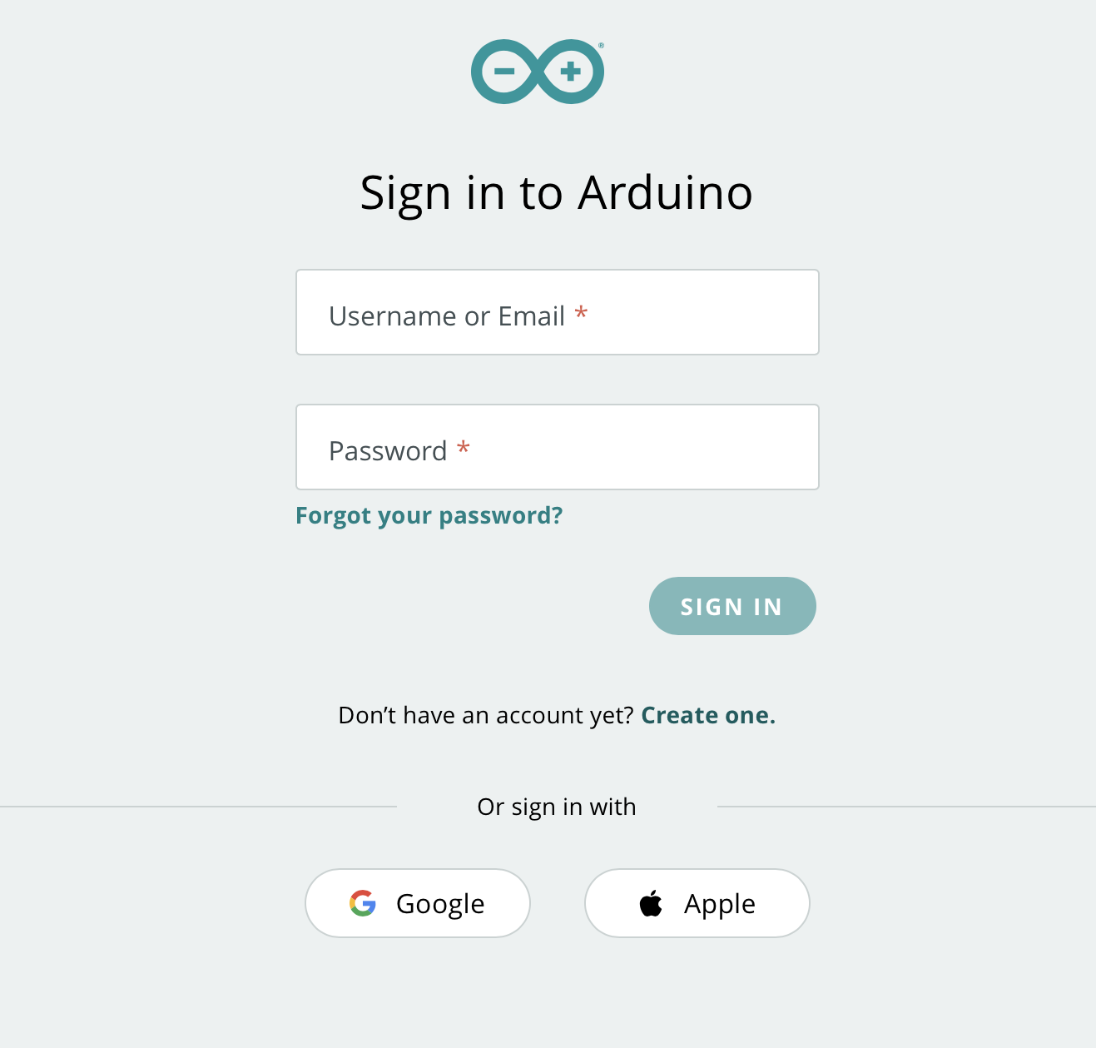
Click on the ‘Create one’ link.
Enter your date of birth and then click on next.
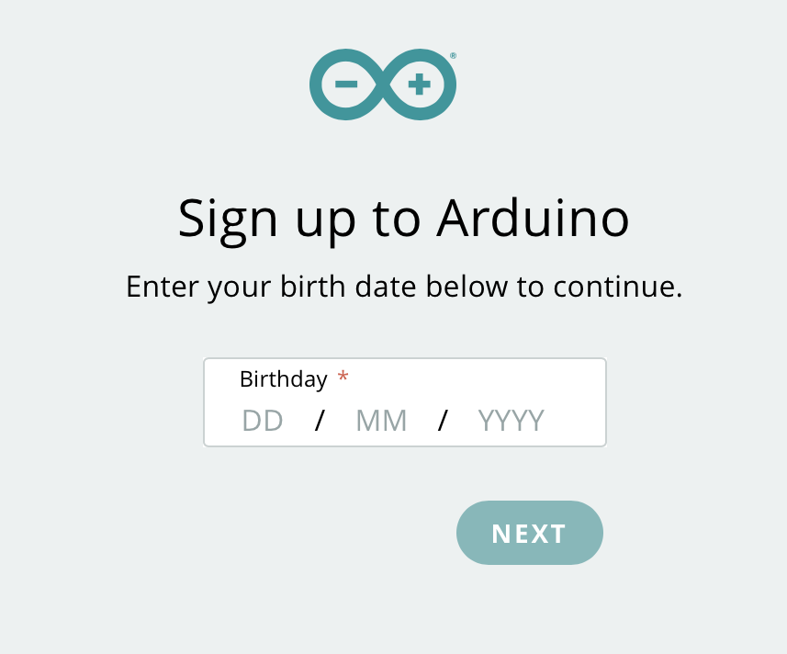
Enter your email, username and password. You also need to tick that you have read and accepted the privacy policy.

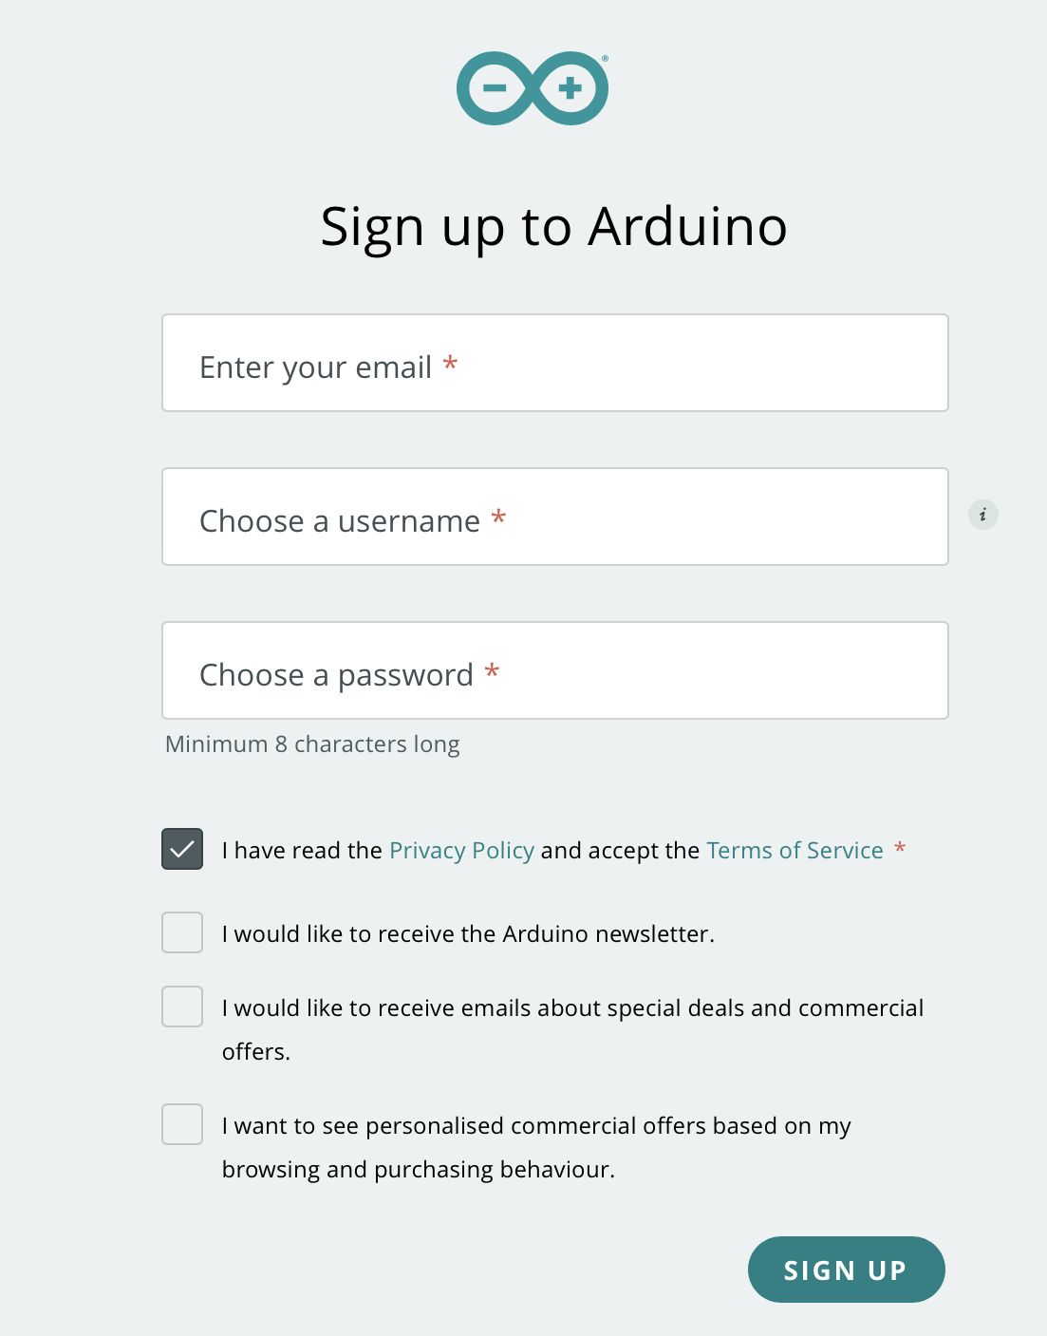
You will then have created your own account on the Arduino Cloud.

Pro tip

Remember to choose a secure password that you can remember, as you will need these details for all Arduino IoT projects.

You are now going to explore the Arduino Cloud IDE by creating your first project. You should sign into: https://create.arduino.cc/. Use the account details that you set up above.

Adding your device for the first time

The first time that you use your Arduino, you will need to connect it to your account. To do this click on ‘Devices’ and then ‘Add Device’.
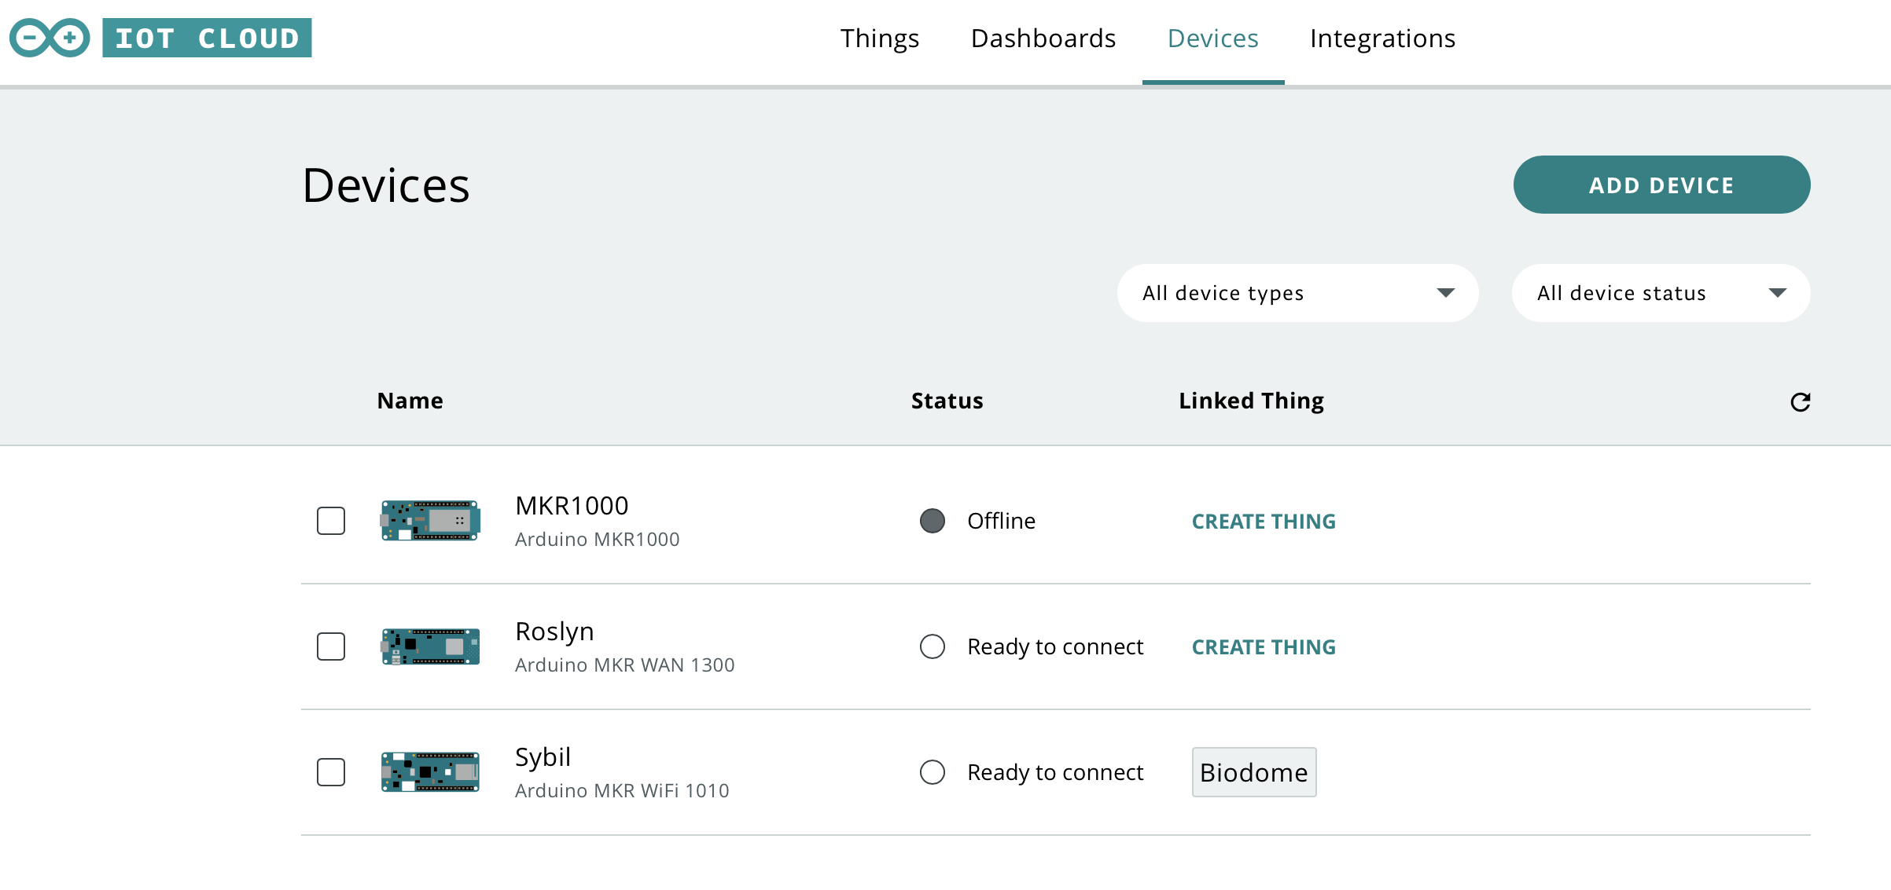
Select ‘Set up an Arduino Device’.
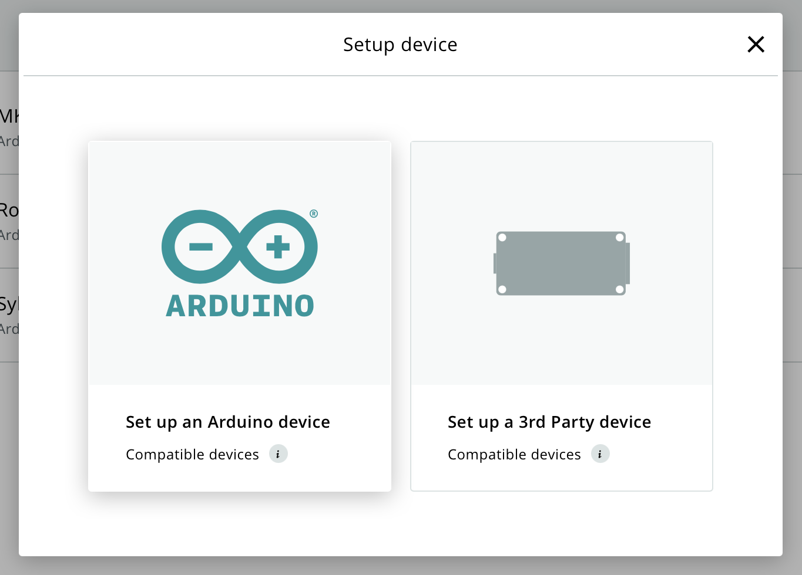
Connect your device to your Computer using a USB cable.

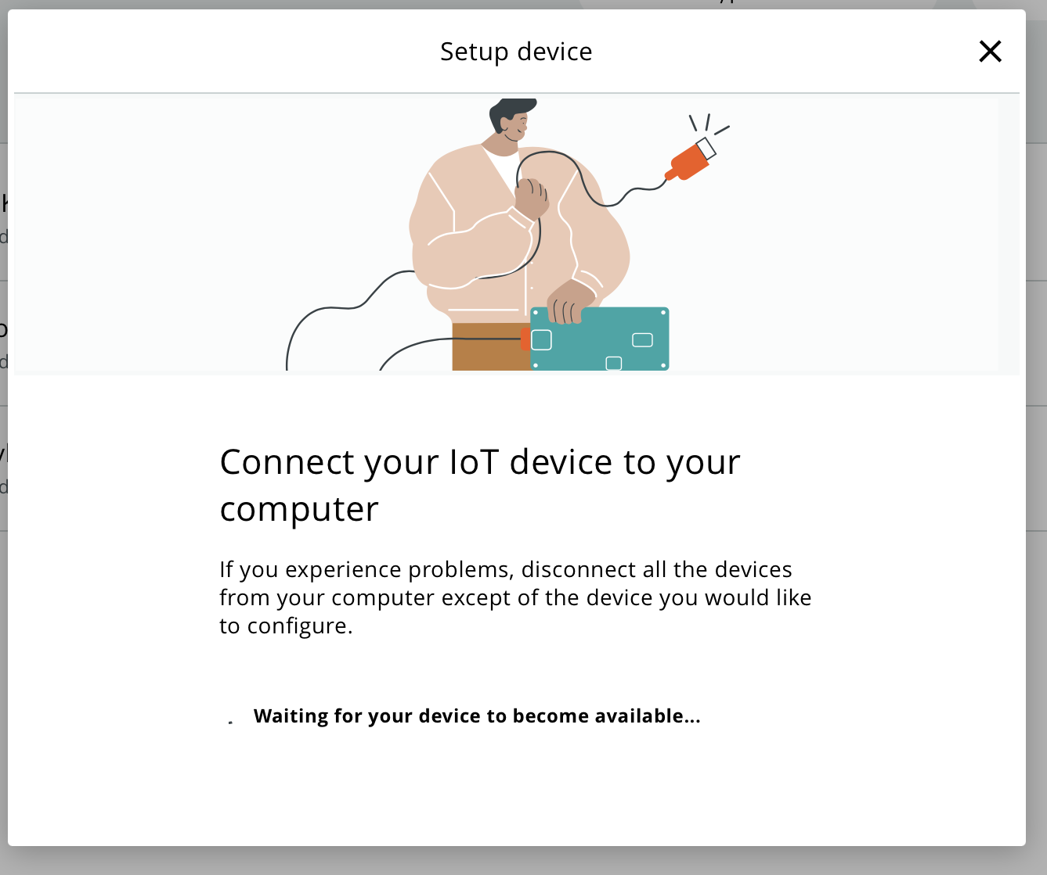
You will then see your device. In this example, the MKR WAN 1300 has been used. The model of Arduino that you are using will be displayed in the window. Click on ‘Configure’.

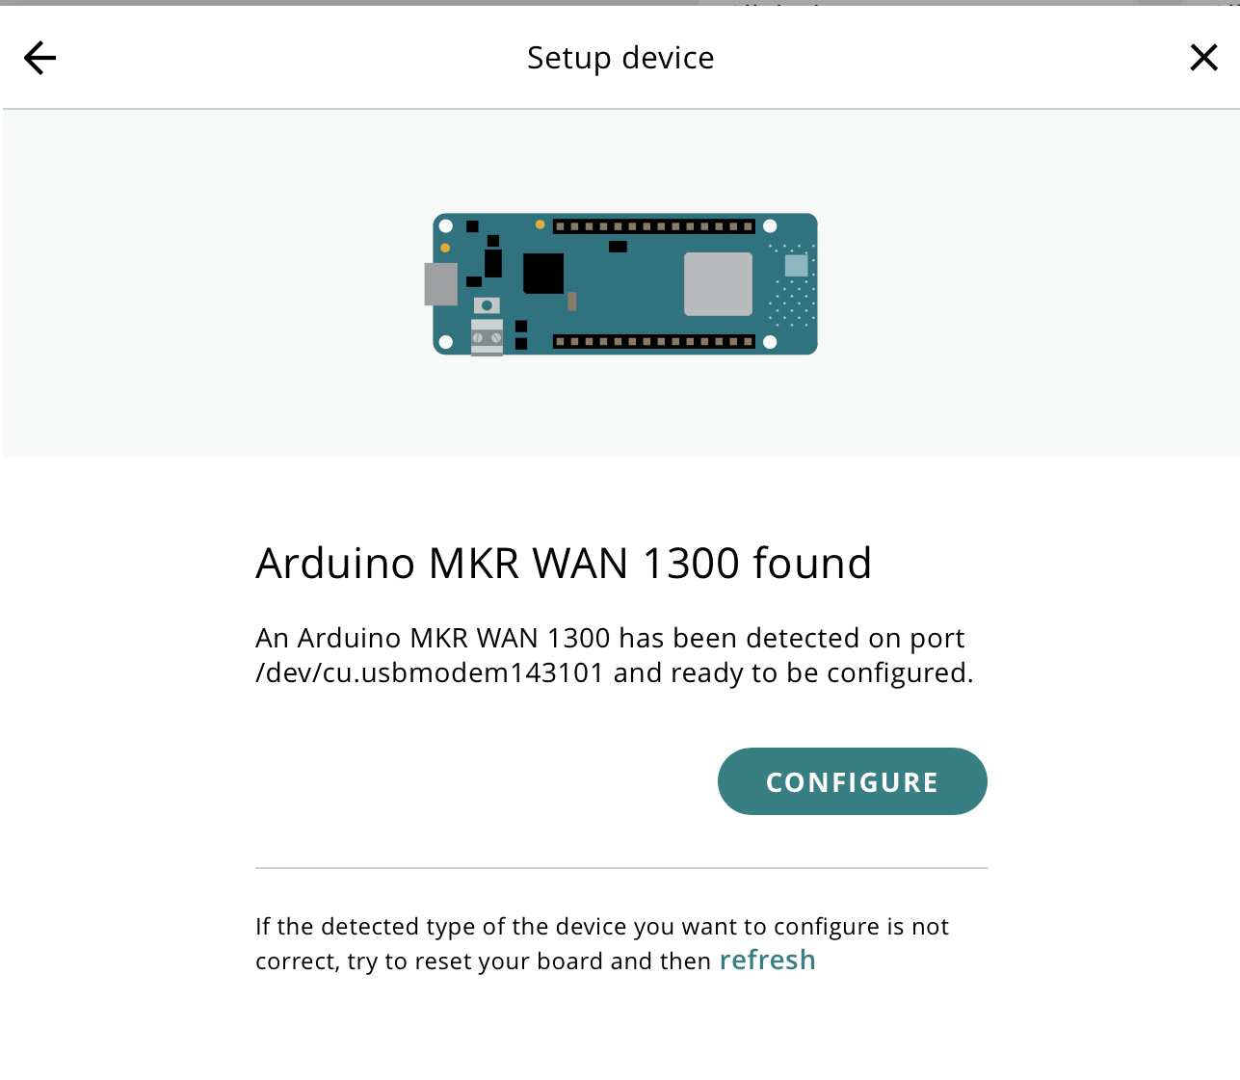
Enter a name for your device and click on ‘Next’.
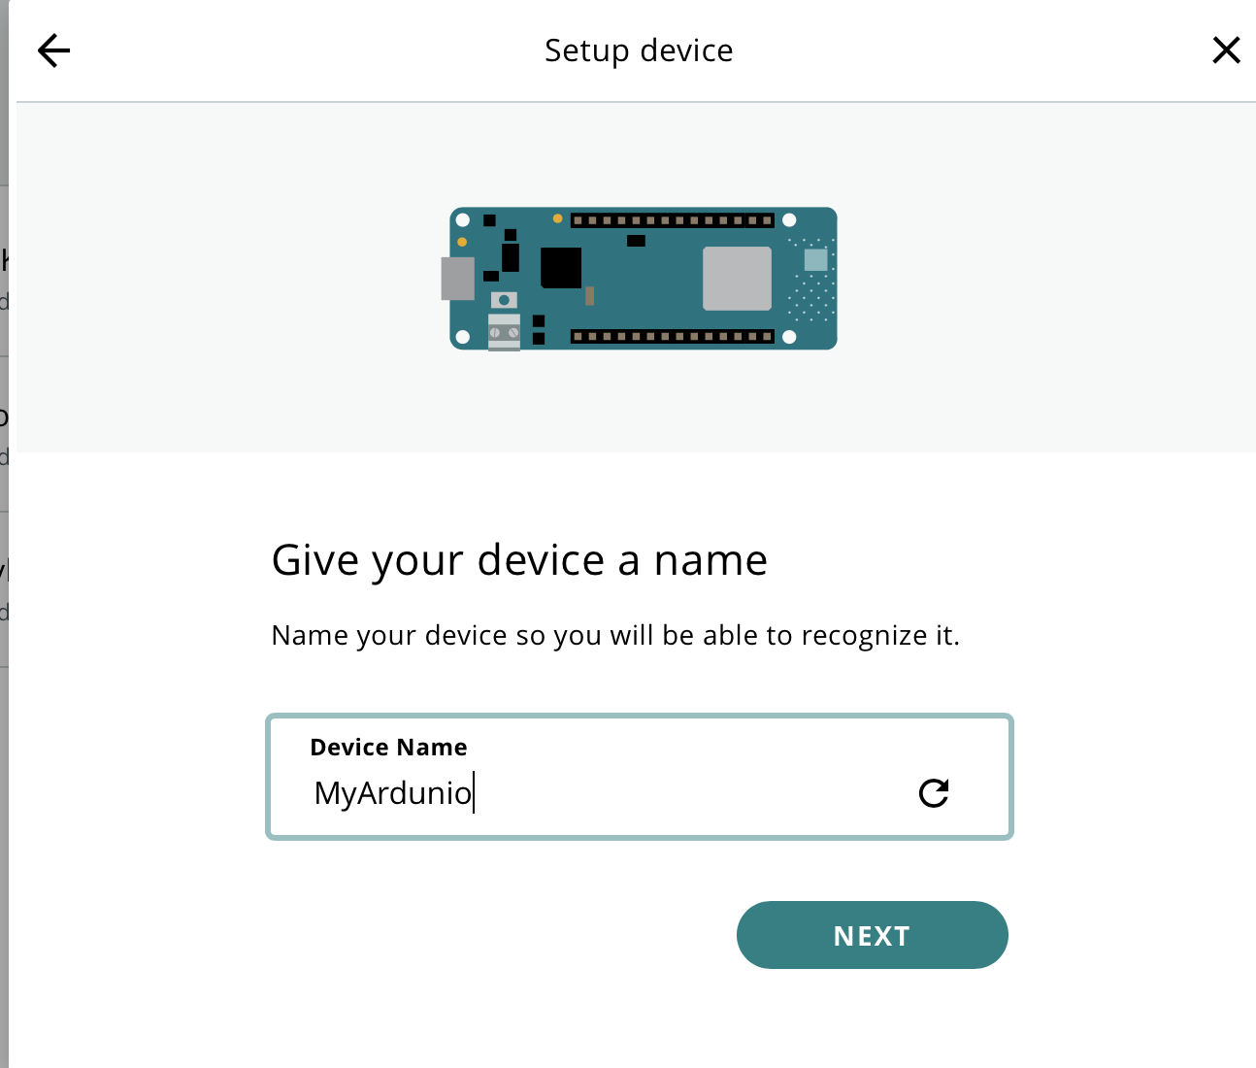

Your device will then be configured ready for use.
You are now going to write your first program. Click on ‘Things’.
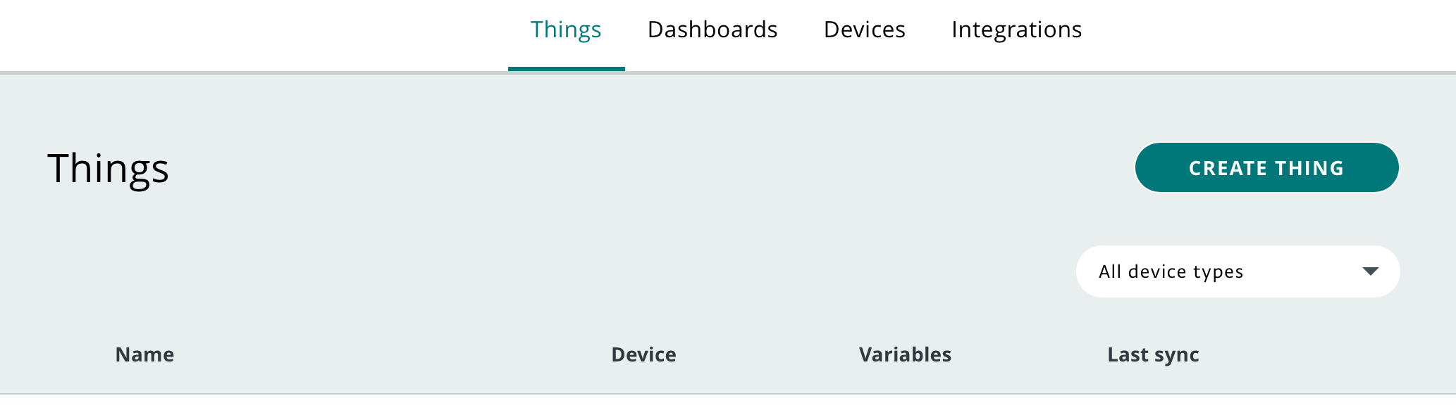
The purpose of this project is to familiarise yourself with the various views which are available on Arduino cloud. At the end of the project, you will be able to remotely turn the built-in LED on and off. The first step is to click on ‘Create Thing’.
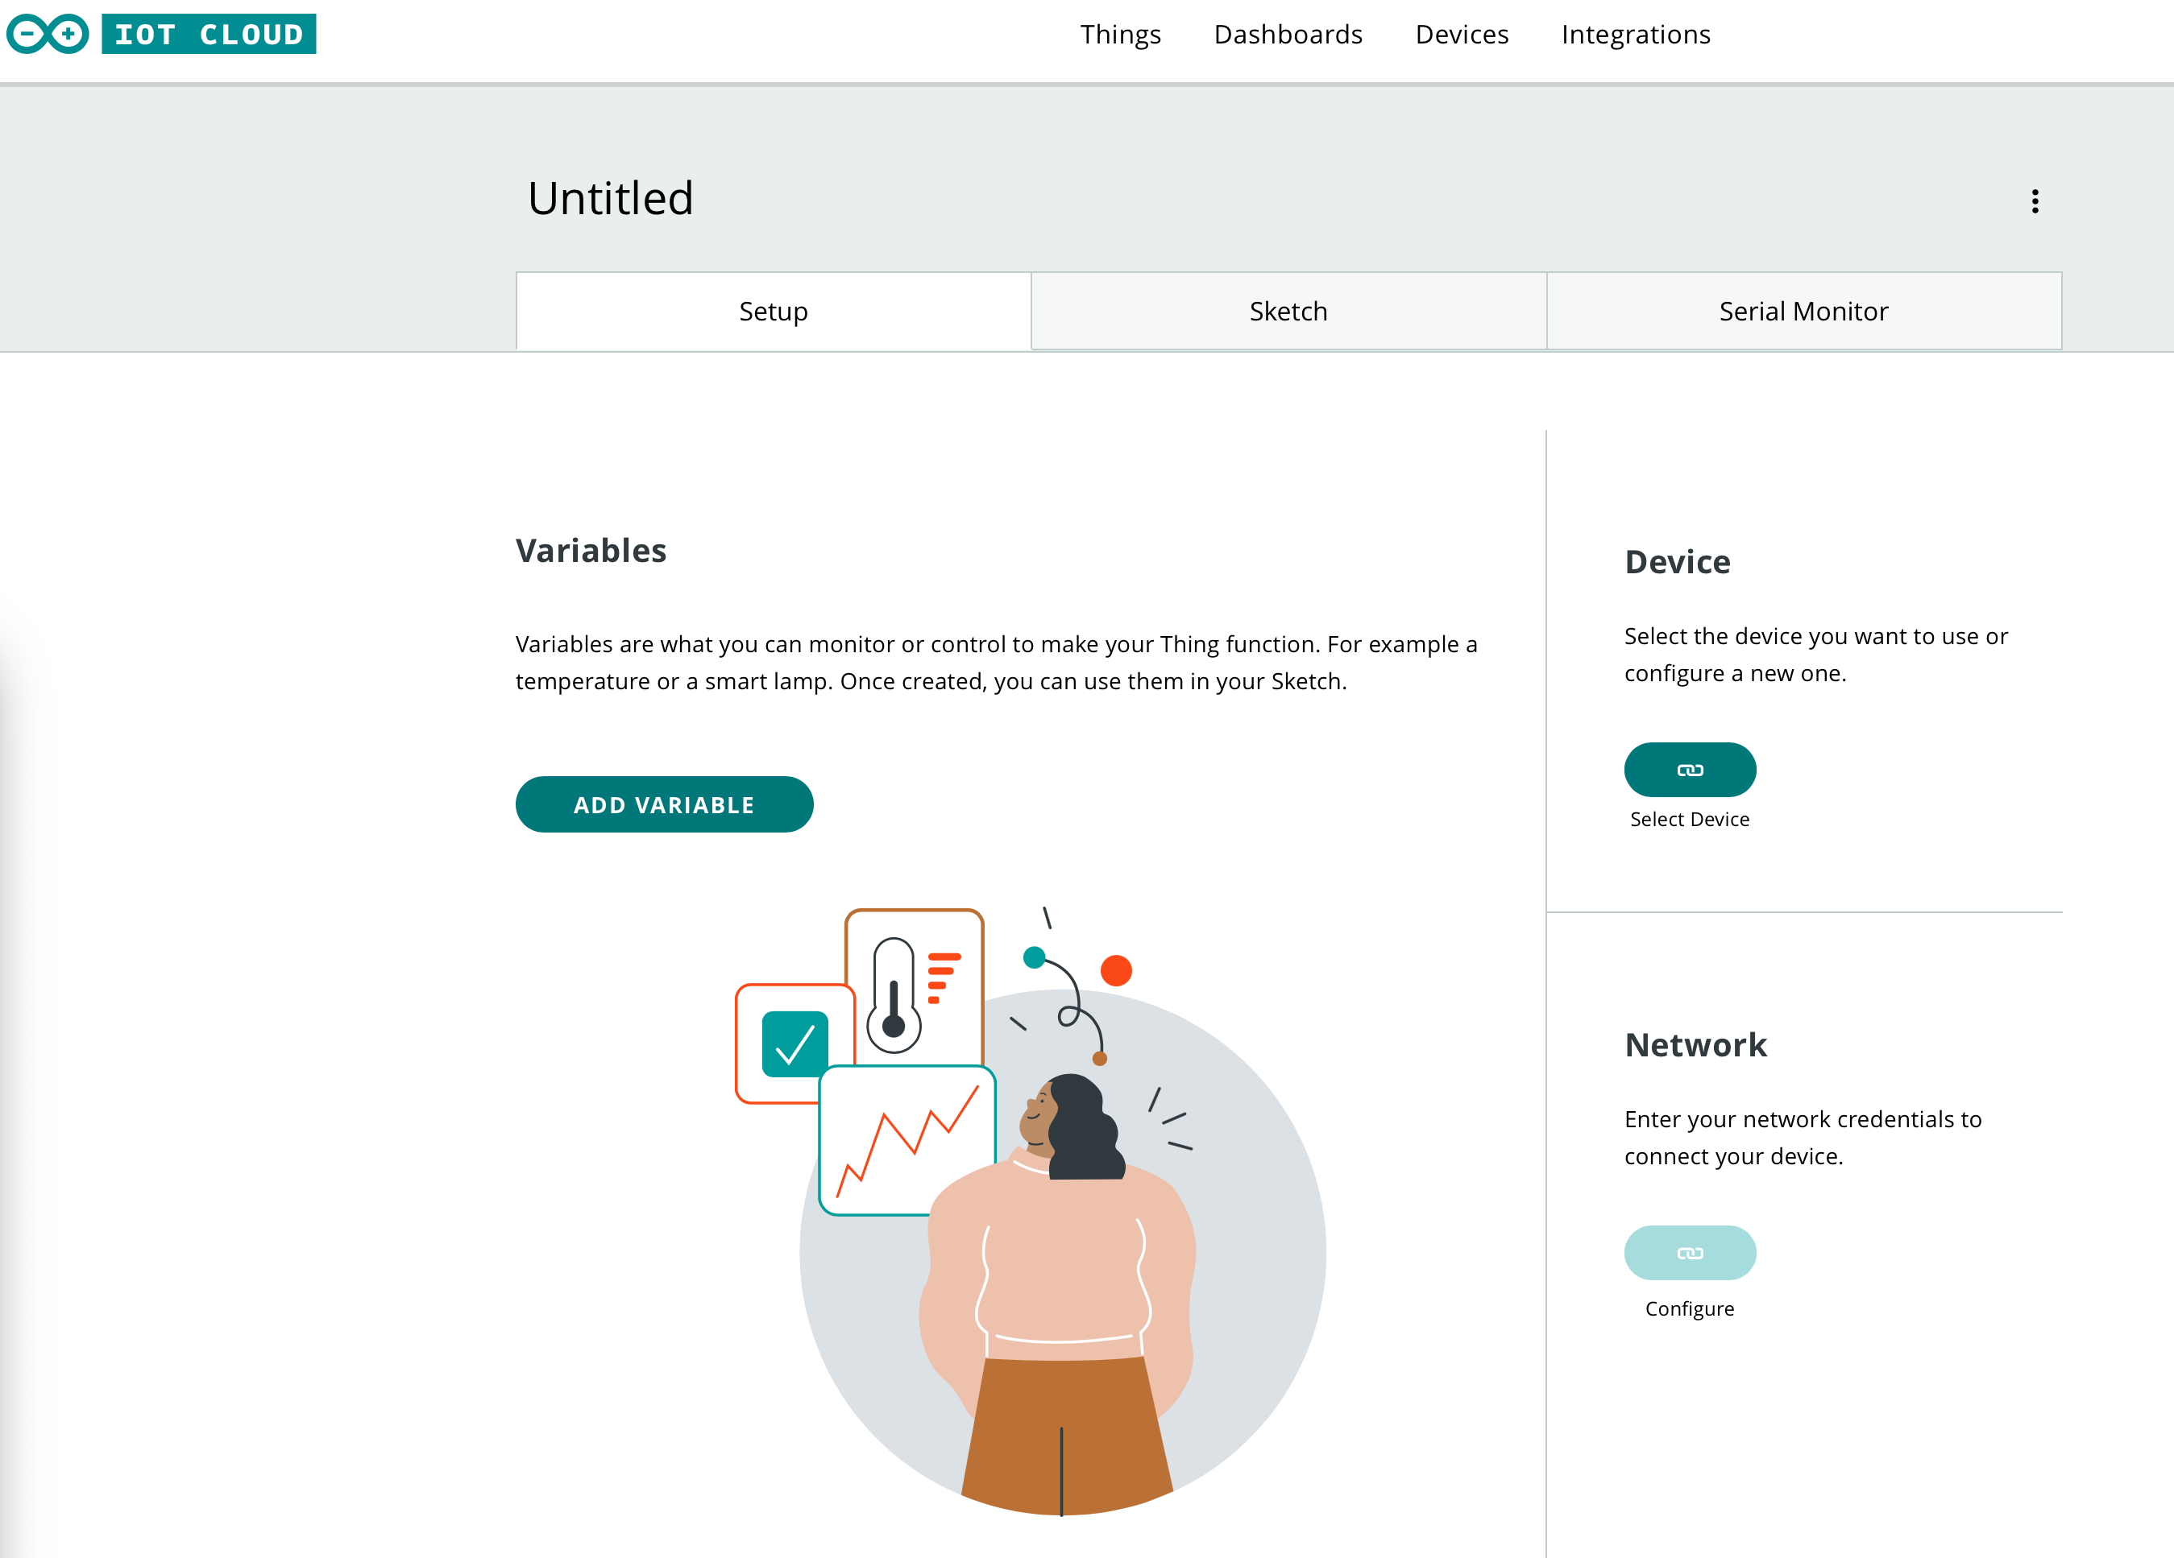
Where is says ‘Untitled’, add the name of your thing. In this example we have called it LEDController. We are also going to connect our device by clicking on the ‘Select Device’ button.
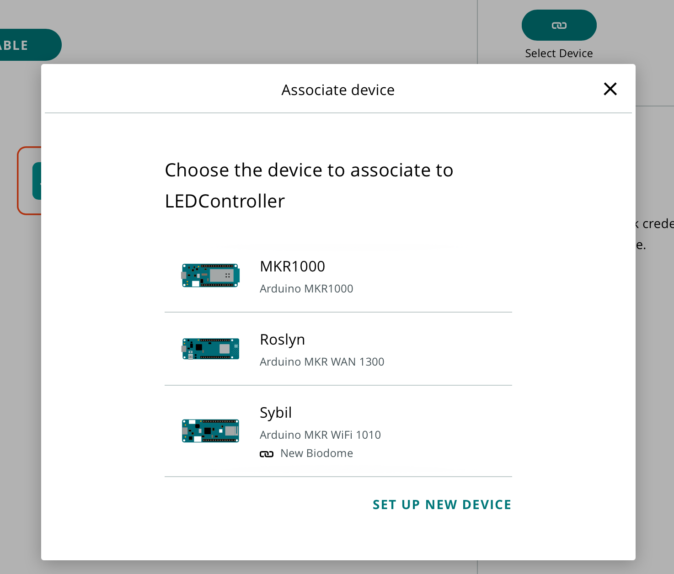
You should then click on the device which you will use to control the LED.
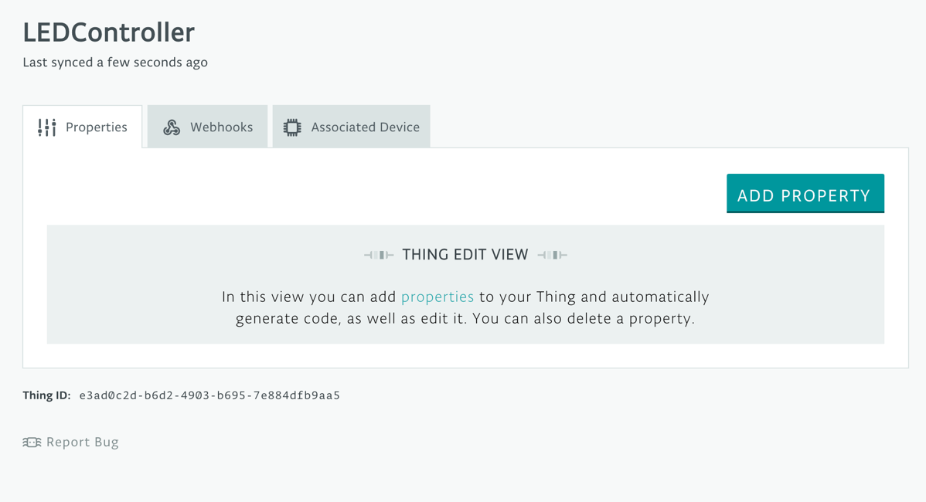

You now need to add code to control your thing. To do this, select ‘Add Variable’.

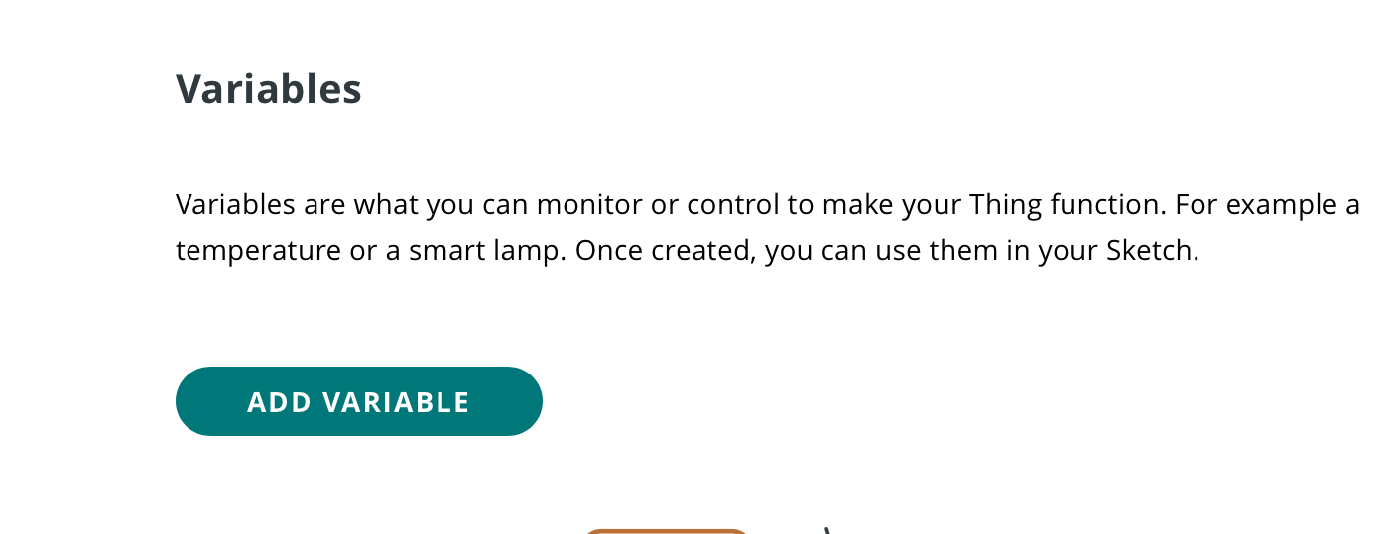

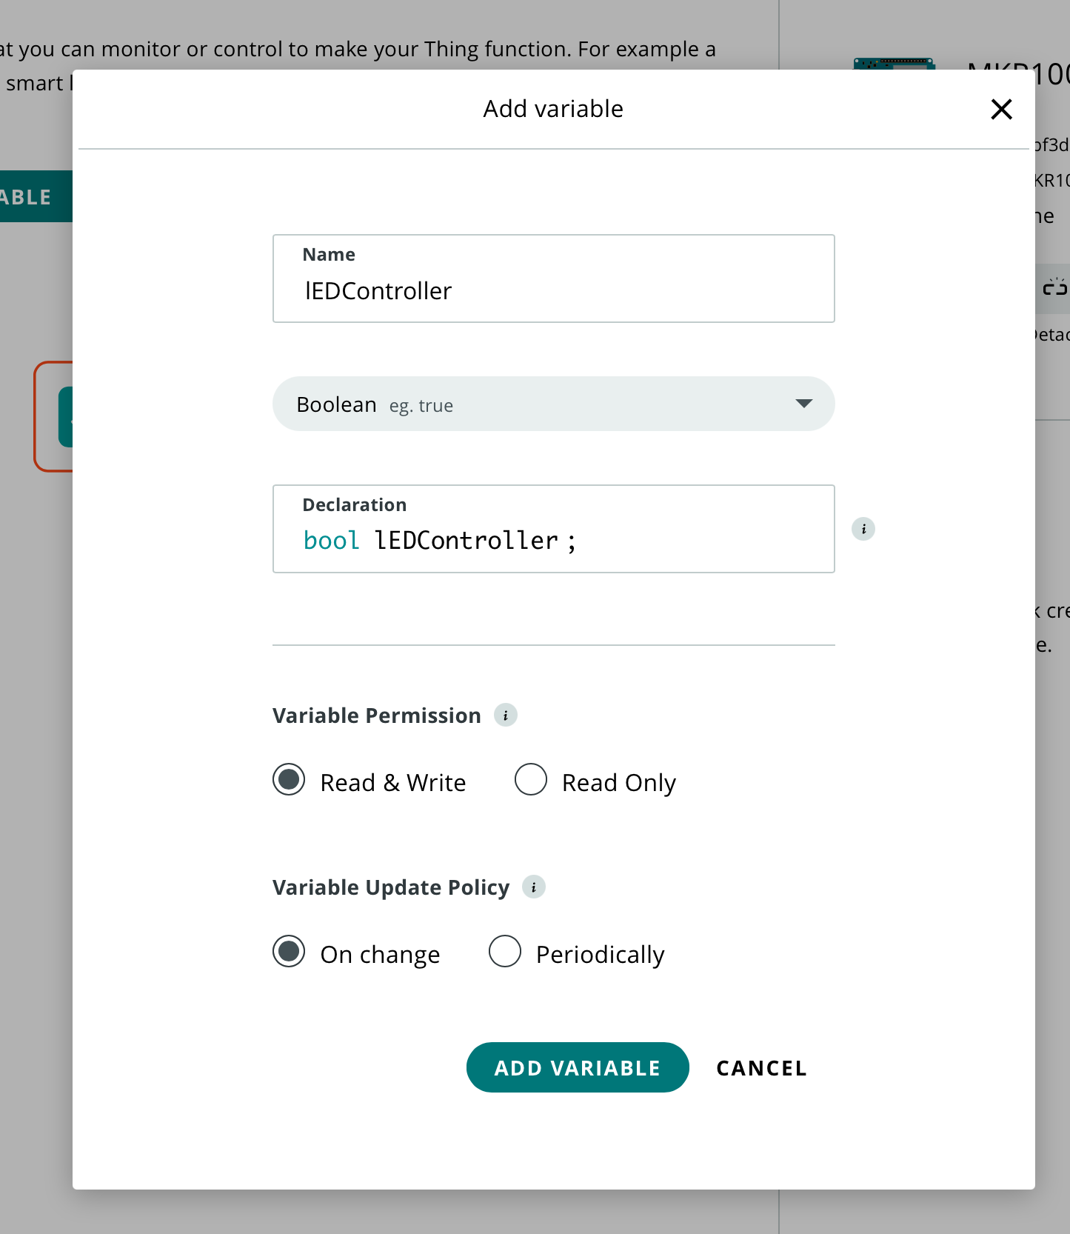
I have named the property LED Controller and it will be controlled using the variable lEDController. As the LED can either be on or off, I have selected that it will be a Boolean data type.
Once you have added the relevant properties, click on ‘Add Variable’.
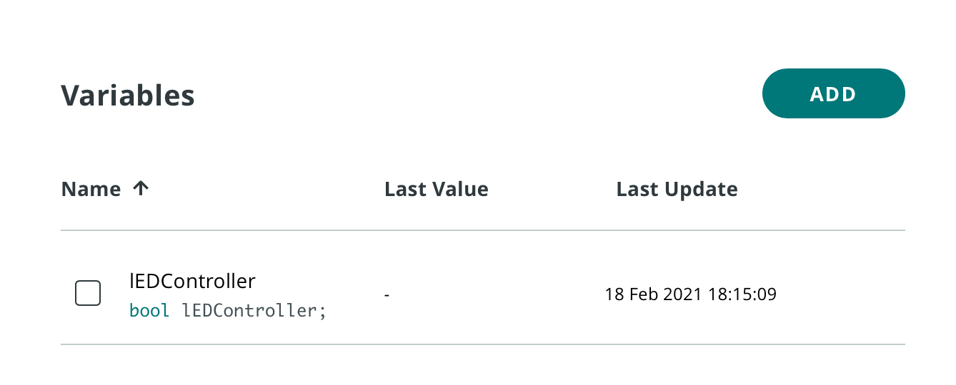
Through adding this variable, the basic code will be automatically generated for you. You now need to add in further code to turn the built in LED on and off.
To do this, select ‘Edit Sketch’. The sketch that you are editing is highlighted by the fact that it appears in white. The other tabs are grey to highlight that they are not currently the active tab which you are editing. You should then click on the sketch tab and open full editor.
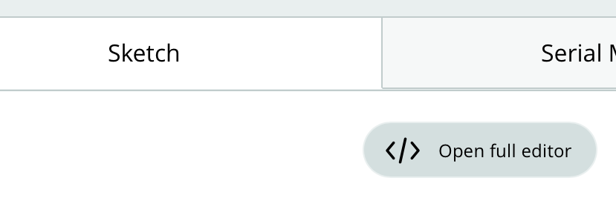

In the screenshot below, you will see that each line has a line number next to it. In your code the line numbers may be different.
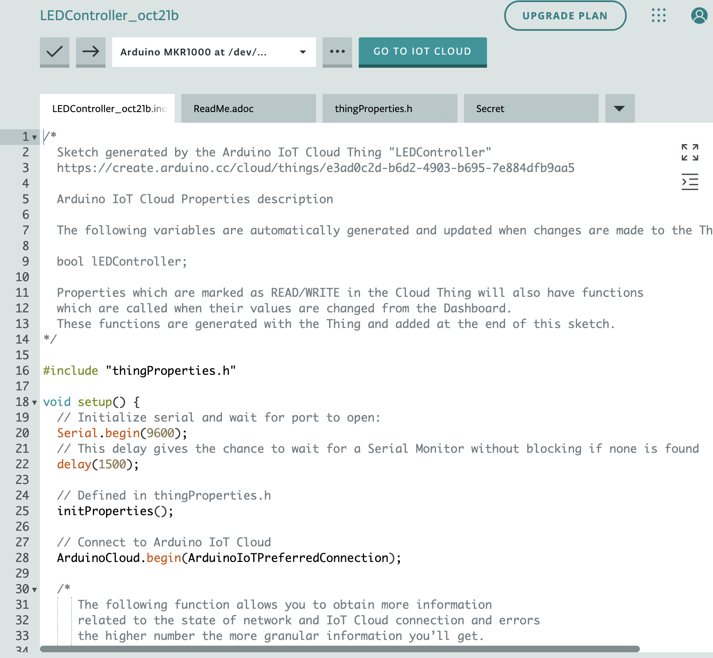

As you can see, there are four different tabs which have been generated for you. The base code is contained on the LEDController tab. The ReadMe tab allows you to add further instructions for the code. The lines on the LEDController tab which are in grey are comments which help you to understand the code. When executing the code these lines are ignored by the computer.
To control the LED, you need to add in two further lines. Please ensure that you add them into the correct location in the code.
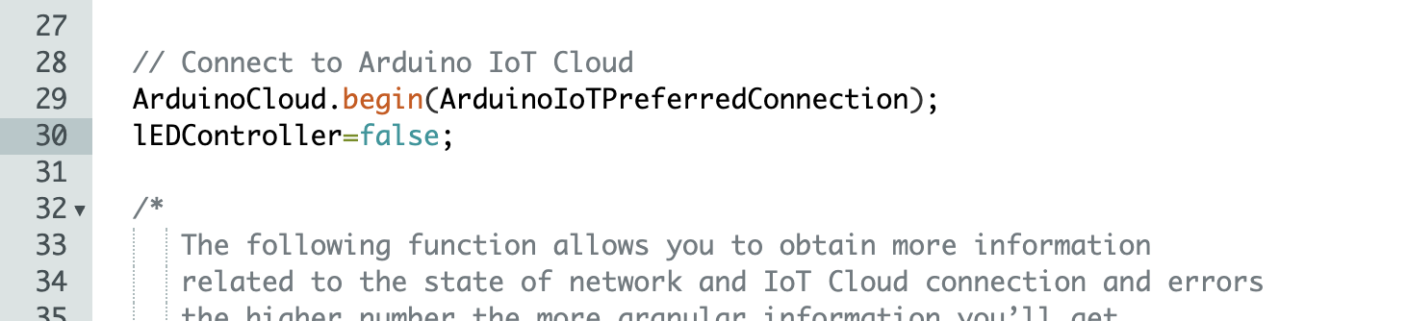

You should add in ‘lEDController=false’ directly after the ArduinoCloud.begin line. This will mean that when the code is initially executed the LED will be turned off.

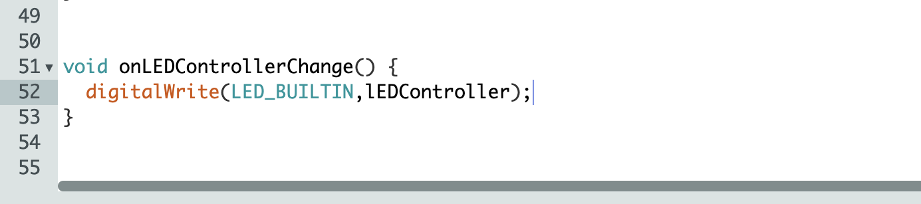
At the end of the code you will see a function named onLEDControllerChange(). This is the function that will be run when the switch is turned on. As we wish to turn the LED on, we add the digitalWrite line.
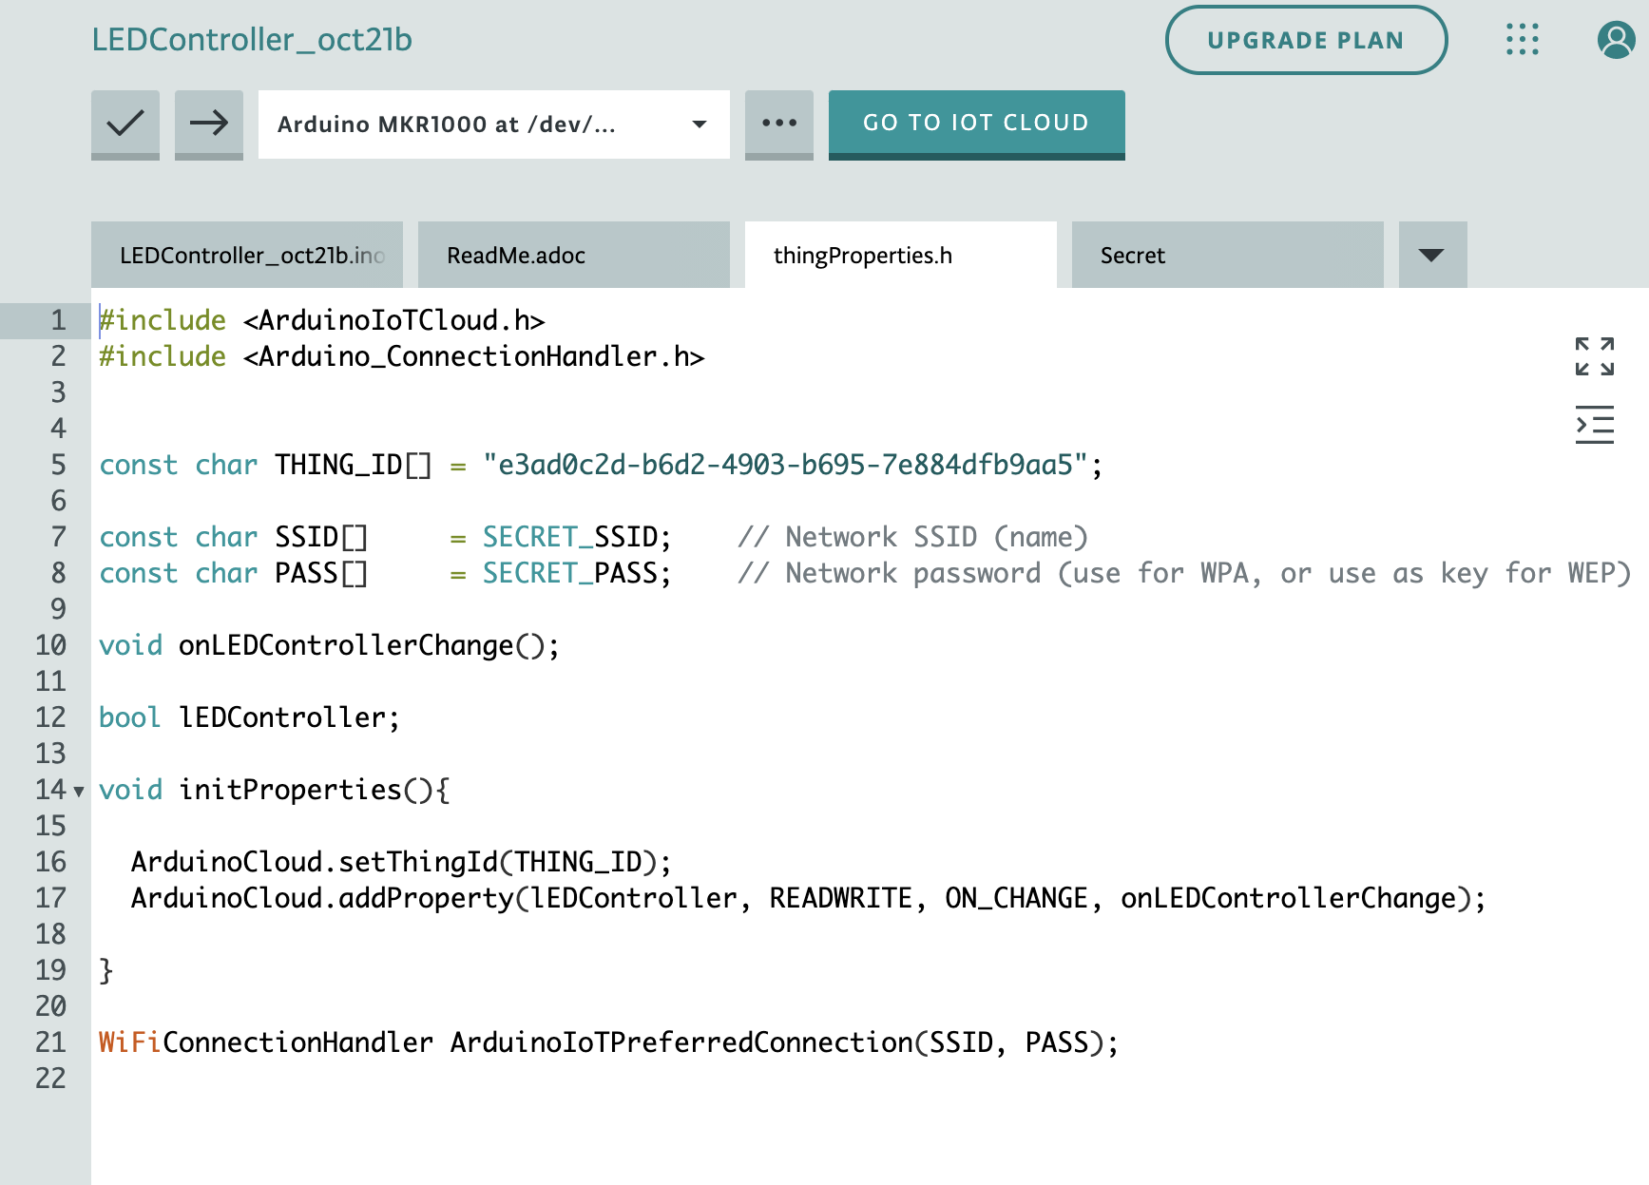

You should now select the thingProperties.h tab. This is a set of code which relates to setting up the cloud device. When you run LEDController, this library is imported into the main program. It makes sense to separate the code into different files as they serve different needs. This aids maintainability. Maintainability refers to the different features which can be added to your code which make it easier for yourself and other programmers to understand the code in the future.
On lines 5, 7 and 8, you will see three constants. These are values which do not change during the running of the program. The THING_ID[] is automatically generated. The SSID and PASS are the name and password for your Wi-Fi network. These values are fetched from the Secret tab.
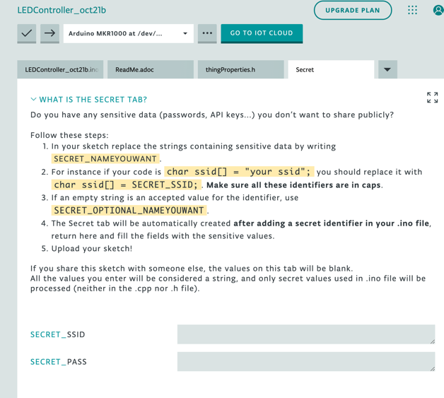
You should now select the ‘Secret’ tab and enter your SSID and Password. Then go back to the thingProperties.h tab.
On line 12, you will see the Boolean variable which you created at the start of this project.
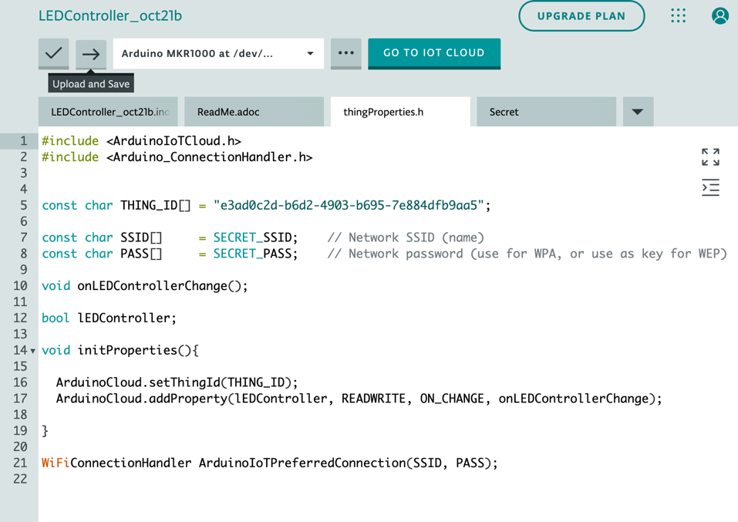

You now need to check your code meets the rules of the language; i.e. that there aren’t any syntax errors. Click on the arrow pointing to the name of your Arduino. Once the code has been checked, you will either see a success message or details of any errors.
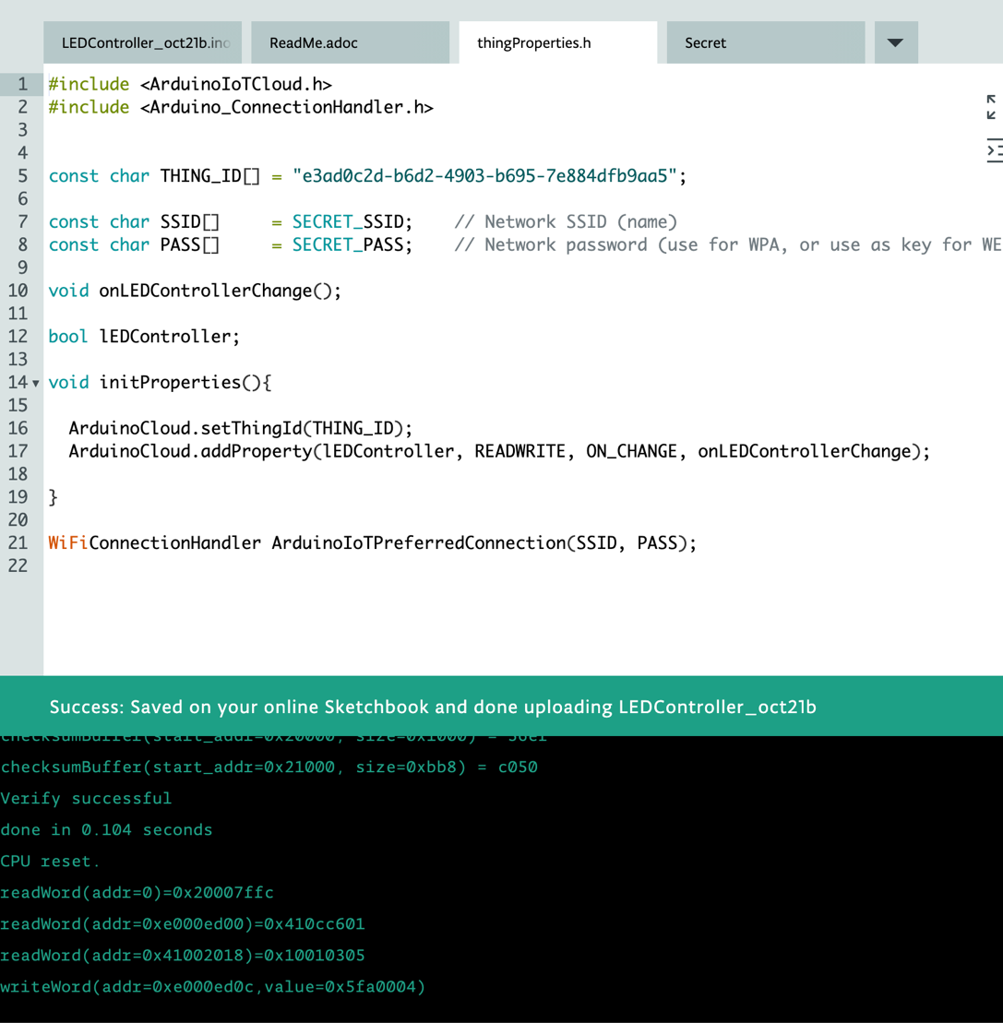
You should now select ‘Go to IoT cloud’. You will now create a button to control your LED. Click on ‘Dashboards’ and create a new dashboard.
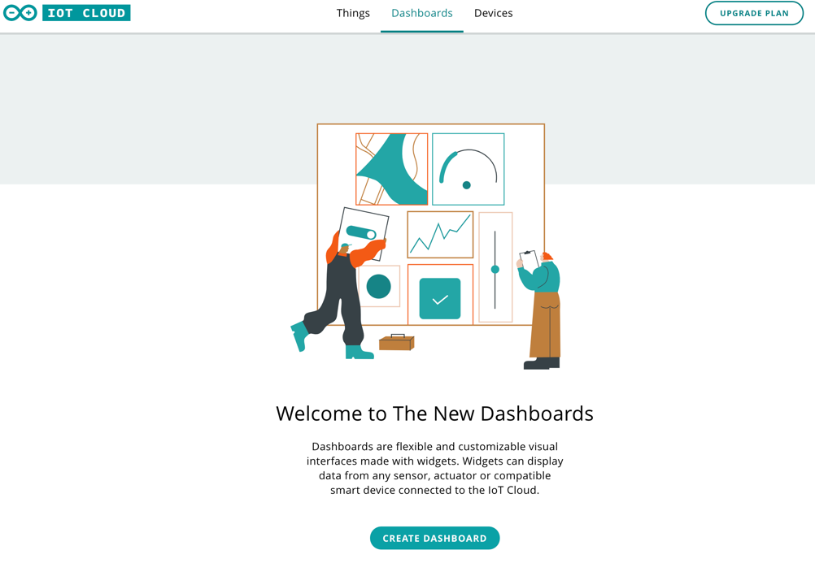
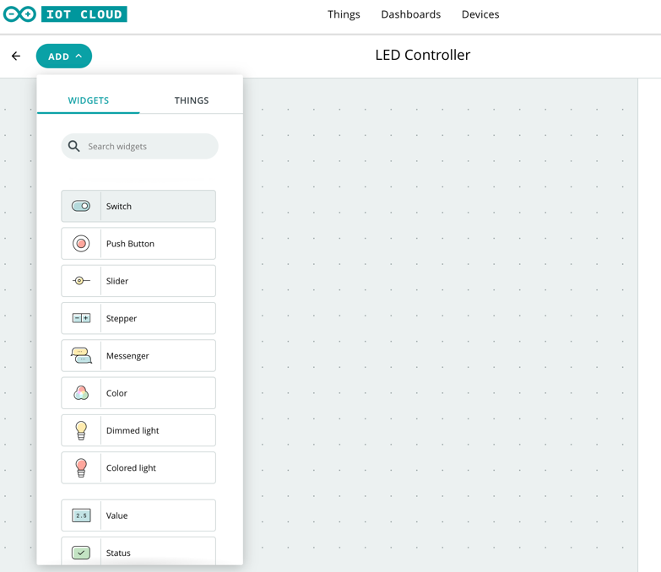

Upon selecting ‘Create dashboard’, you are presented with a list of different input and outputs. Select ‘Switch’.
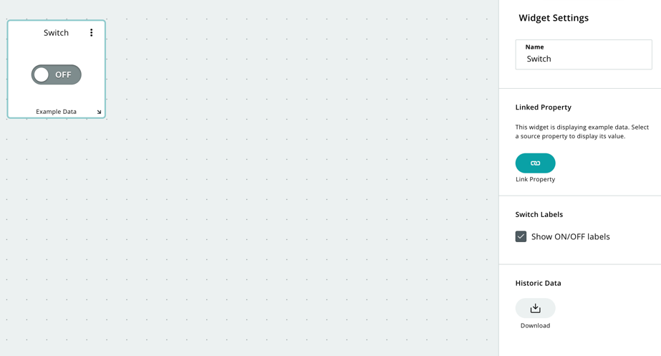
You should then click on ‘Link property’ and choose the variable which you defined at the start.
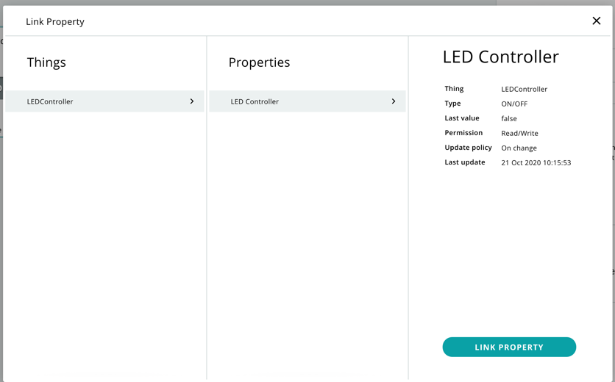
Click on ‘Link property’ again.
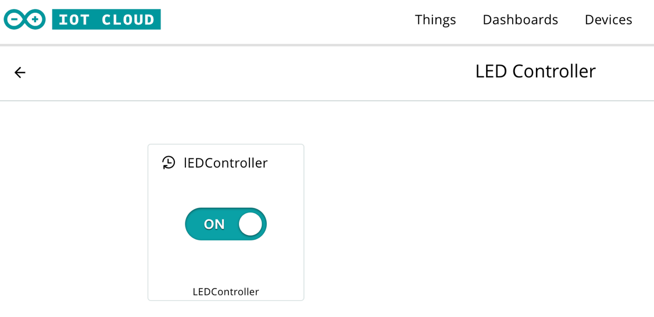
You will then be presented with your switch, which will turn the LED on and off.

Testing

To use your Dashboard, you should click on ‘Use Dashboard’.

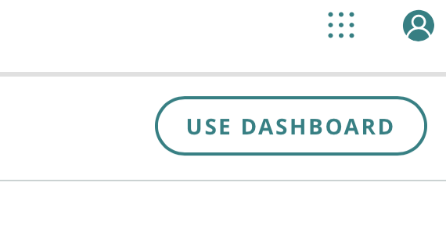
You should now test your program. When you switch the slider to ‘On’, the LED should turn on. When you switch it to ‘Off’, the LED should turn off.

Stretch task

Expand your device to build your own circuit to control an external LED.

